LOCAL AND GLOBAL VARIABLE, RUNNIG TOTALS AND STRINGS AND LOOPS

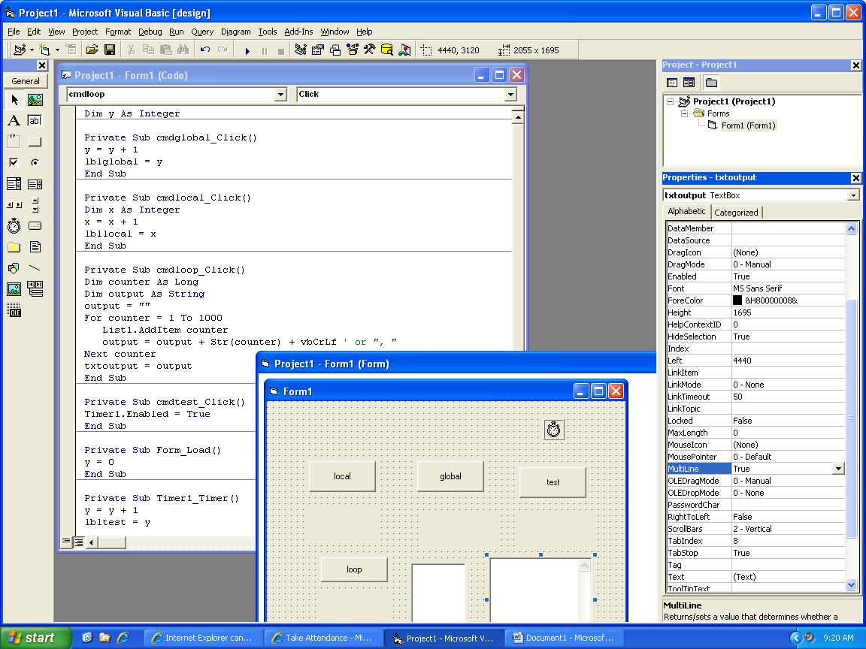

General

Dim y As Integer

Private Sub cmdglobal_Click()

y = y + 1

lblglobal = y

End Sub

Private Sub cmdlocal_Click()

Dim x As Integer

x = x + 1

lbllocal = x

End Sub

Private Sub cmdloop_Click()

Dim counter As Long

Dim output As String

output = ""

For counter = 1 To 1000

List1.AddItem counter

output = output + Str(counter) + vbCrLf ' or ", "

Next counter

txtoutput = output

End Sub

Private Sub cmdtest_Click()

Timer1.Enabled = True

End Sub

Private Sub Form_Load()

y = 0

End Sub

Private Sub Timer1_Timer()

y = y + 1

lbltest = y

End Sub